Alexander Cannell

09/15/2016

CSIA 6000

Cloud Security

**This assignment is based on the Exercise in your Book, Chapter 4: Securing Cloud Computing Systems, page 126. This assignment has three parts *(Parts 1 & 2 must be submitted individually here in Word Doc format; Part 3 - Collaboration document just needs to be shared with me, the instructor)*:**

**1. Problem**: Answer the following question as it relates to your organization (speak in general terms, does not need to be specific, and you can change the names to protect the innocent...;-)

* Does a cloud solution (i.e. can be any cloud solution, not just Amazon, if your organization has explored this option) offer equal or greater data security capabilities than those provided by your organization's in-house solutions?

I work for Ancestry.com. We are a web based company that provides genealogy services to an international clientele, we also provide DNA kits which tells what percentage of your DNA comes from which part of the world. I included a picture of my DNA test below. (You should take the test Rob. Really interesting) Right now Ancestry.com isnt strictly a cloud website, the majority of the site is run on inhouse solutions. Ancestry has determined that they are going to a cloud based computing within the next year or two. My company has already weighed the pros and cons, but I wasn't in that meeting so I will do so now here. Reading in the book it looks like we would be going to a private cloud computing over the public cloud. We handle a lot of data and that data needs to be secure. The book gives us potential risks of cloud computing, almost all of which we deal with on locally hosted servers. Something new I learned about was there is something called an Economic Denial of Service which is an attack meant to disrupt or destroy economic resources. The greatest problem I see with transferring over to the cloud will be the actual transfer of current data, implementation, and employees education of the cloud environment. One of the benefits of inhouse is more control of physical security, but the added bonus of cloud people dont know where your website is physically at. The majority of the company is getting certified on AWS(Amazon Web Services), I believe that is who we are going with for our Cloud Platform. From my knowledge cloud computing has greater data security capabilities than we currently possess.

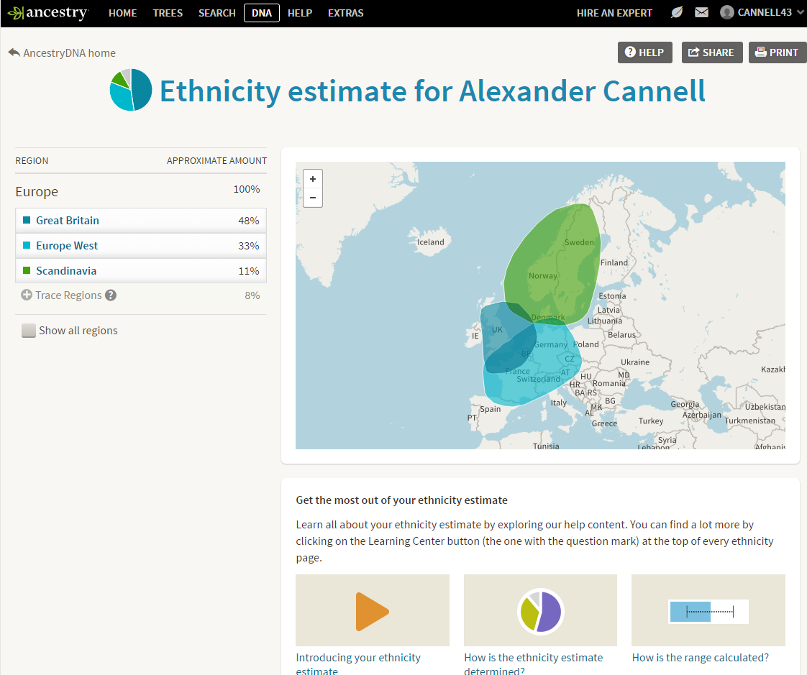

**2. Hands-on Project**: Based on the cloud solution you addressed under the Problem section above, what vulnerabilities can you identify, or has the industry identified in association with that cloud solution?

As I stated above the cloud solution will be the best possible solution. We are heading that direction within the next year or two. A Con the change will get rid of alot of jobs at ancestry, which i think they will move to other departments. This will take away from development because of the time spent on implementation, and education. Another problem I have come across is with security there will be alot of things that the cloud doesnt secure properly, like data breaches , data loss, man in the middle, Insecure Applications, DoS, threats from the inside… These are all security threats that on premise infrastructures have to deal with. There will be alot of customization of the cloud service for ancestry to meet our security compliance standard needs like PCI, and HIPPA. There will be a lot of customization in general to meet some of ancestry’s other requirements like new relic monitoring. Another Security issue ultimately the data resides in the control of the vendor, not the company. I feel like that would be an issue with payment, and personal information. A possible solution would be to have those two services be in house rather than on the cloud. I know this is an obvious but We need to have constant and reliable internet for the cloud, maybe a direct ISP for operations to handle issues. Our internet company has been pretty great, but the costs are pretty bad. I believe that cloud will be the best for ancestry, but there will be alot of work to get us to that point.

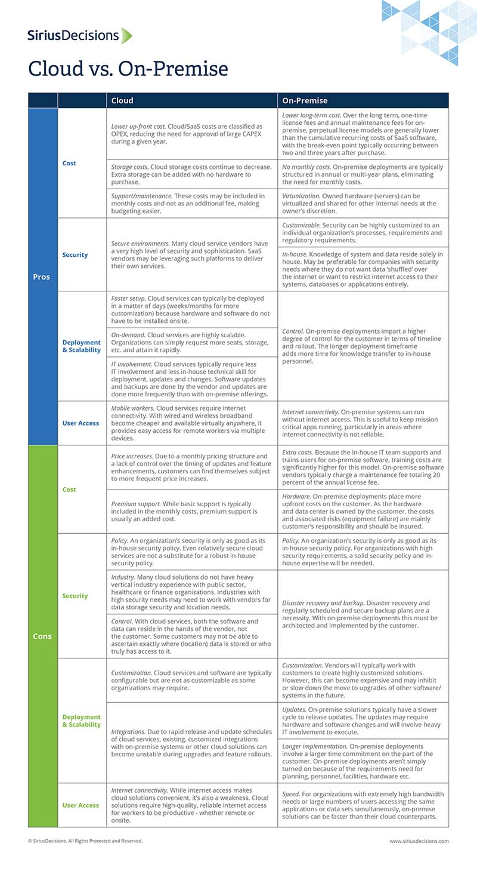

Cited Works:

<https://www.siriusdecisions.com/Blog/2014/Dec/Cloud-vs-On-Premise-The-Pros-and-Cons>

<https://aws.amazon.com/choosing-a-cloud-platform/?sc_channel=PS&sc_campaign=acquisition_US&sc_publisher=google&sc_medium=cloud_computing_hv_b&sc_content=sitelink&sc_detail=aws&sc_category=cloud_computing&sc_segment=choosing_a_cloud_platform&sc_matchtype=e&sc_country=US&s_kwcid=AL!4422!3!102882733962!e!!g!!aws&ef_id=VmtAYQAAAH7DsvCs:20160916150731:s>

<http://www.onlinetech.com/resources/references/public-vs-private-cloud-computing>

<http://web.a.ebscohost.com.proxy.li.suu.edu:2048/ehost/ebookviewer/ebook/bmxlYmtfXzU5NjYzNV9fQU41?sid=0d76c035-d65a-4b35-989e-f073016e19a8@sessionmgr4008&vid=0&format=EB&lpid=lp_83&rid=0>